1.PING command

- The ping command is a Command Prompt command used to test the ability of the source computer to reach a specified destination computer.
- It's usually used as a simple way to verify that a computer can communicate over the network with another computer or network device.
- The ping command operates by sending Internet Control Message Protocol (ICMP) Echo Request messages to the destination computer and waiting for a response.
Ping Command Options
Item | Explanation
-t | Using this option will ping the target until you force it to stop by using Ctrl+C.
-a | This ping command option will resolve, if possible, the hostname of an IP address target.
-n count | This option sets the number of ICMP Echo Requests to send, from 1 to 4294967295. The ping command will send 4 by default if -n isn't used.
-l size | Use this option to set the size, in bytes, of the echo request packet from 32 to 65,527. The ping command will send a 32-byte echo request if you don't use the -l option.

Steps
1. Open cmd in windows
Ping google.com
> ping -n 5 -l 1500 www.google.com

2.Ping localhost
ping 127.0.0.1

3. Find Hostname With Ping
ping -a 192.168.137.254

How to find ip address of host

C:\Users\HP> nslookup google.com
DNS request timed out.
timeout was 2 seconds.
Server: UnKnown
Address: 192.168.137.254

DNS request timed out.
timeout was 2 seconds.
Name: google.com
Address: 2404:6800:4007:820::200e

4) Ping Router Command
ping 192.168.2.1
Similar to the ping command examples above, this one is used to see if your computer can reach your router.

How to find router ip address
Step 1:
Right-click the Start button then select Command Prompt.

Step 2:
On the Command Prompt window, enter “ipconfig” and press the [Enter].
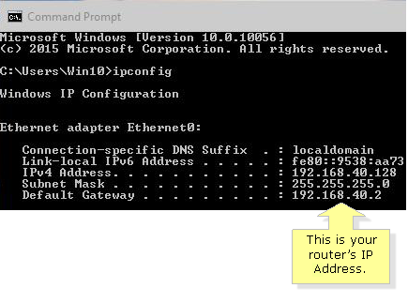

5)Ping With IPv6
ping -t -6 SERVER
In this example, we force the ping command to use IPv6 with the -6 option and continue to ping SERVER indefinitely with the -t option

2. Using the Traceroute (tracert) Command

What is the traceroute command?

The tracert command is a Command Prompt command that's used to show several details about the path that a packet takes from the computer or device you're on to whatever destination you specify.

C:\Users\HP>tracert /?

Usage: tracert [-d] [-h maximum_hops] [-j host-list] [-w timeout]
[-R] [-S srcaddr] [-4] [-6] target_name

Options:
-d Do not resolve addresses to hostnames.
-h maximum_hops Maximum number of hops to search for target.
-j host-list Loose source route along host-list (IPv4-only).
-w timeout Wait timeout milliseconds for each reply.
-R Trace round-trip path (IPv6-only).
-S srcaddr Source address to use (IPv6-only).
-4 Force using IPv4.
-6 Force using IPv6.

Tracert Command Options
Item | Description
-d | This option prevents tracert from resolving IP addresses to hostnames, often resulting in much faster results.
-h MaxHops | This tracert option specifies the maximum number of hops in the search for the target. If you do not specify MaxHops, and a target has not been found by 30 hops, tracert will stop looking.
-w TimeOut | You can specify the time, in milliseconds, to allow each reply before timeout using this tracert option.
-4 | This option forces tracert to use IPv4 only.
-6 | This option forces tracert to use IPv6 only.
target | This is the destination, either an IP address or hostname.
/? | Use the help switch with the tracert command to show detailed help about the command's several options.

$> tracert 192.168.137.90

the tracert command is used to show the path from the networked computer on which the tracert command is being executed by a network device, in this case, a router on a local network, that's assigned the 192.168.137.90
IP address.

tracert www.google.com
With the tracert command shown above, we're asking tracert to show us the path from the local computer all the way to the network device with the hostname www.google.com.
a) How to find the A record of а domain.
You can use this command to see how many A records are there and see the IP Addresses of each one.
A record => The A Record points your hostname to an IP address. This is one of the most frequently used records in the DNS Zones and it is an essential part of your DNS configuration.

Command line:
$ nslookup google.com

b) How to check the NS records of a domain.
By checking the NS records, you can see which the authoritative server for a specific domain is.

NS= The NS records identify the name servers, responsible for your DNS zone.

Command line:
$nslookup -type=ns google.com

c) How to find all of the available DNS records of a domain.
This lookup has a large scope. Here we want to see all the available DNS records. After seeing all of them, we can do specific lookups for different types of DNS records.

Command line:
$ nslookup -type=any example.com

